**GNANAMANI COLLEGE OF**

**TECHNOLOGY**

Departnament of BioMedical Engineering

III year

**TOPIC : SMART WATER FOUNTAINS**

**TEAM MEMBERS**

**M.ABARNA (620821121002)**

**N.ENISHA (620821121022)**

**R.MOHANADHARSHINI ( 620821121067)**

**J.DIVYAPRIYA (620821121021)**

**K.LOKESHWARI (620821121056)**

**By :**

**R.Mohanadharshini**

**SMART WATER FOUNTAINS**

The basic idea of this Arduino water fountain is to take an input from any external sound source like mobile, ipod, pc etc.., sample sound and brark it down to different voltage ranges, then use the output to turn on various relay . We first used as condensor mic based sound sensor module to perform on the sound sources to spilt the sounds into different voltages ranges. Then the voltage will be fed to op- amp to compare sound level with a. Particular limit The higher voltage range will correspond to a relay switch ON which comprises a musical water fountain operating to the beats and rythms of the song so here we are building this Musical fountain using Arduino and sound sensor

**MATERIALS REQUIRED**

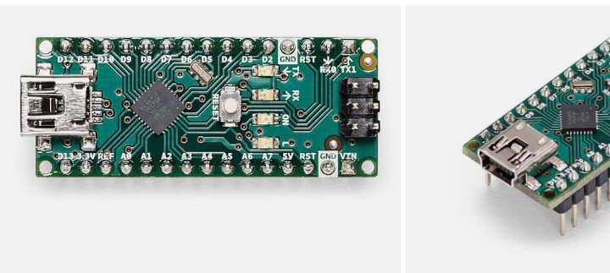

1. Arduino Nano
2. Sound sensor Module
3. 12v Relay module
4. DC pump
5. LEDs
6. Connecting wires
7. Vero based (or) Breadboard

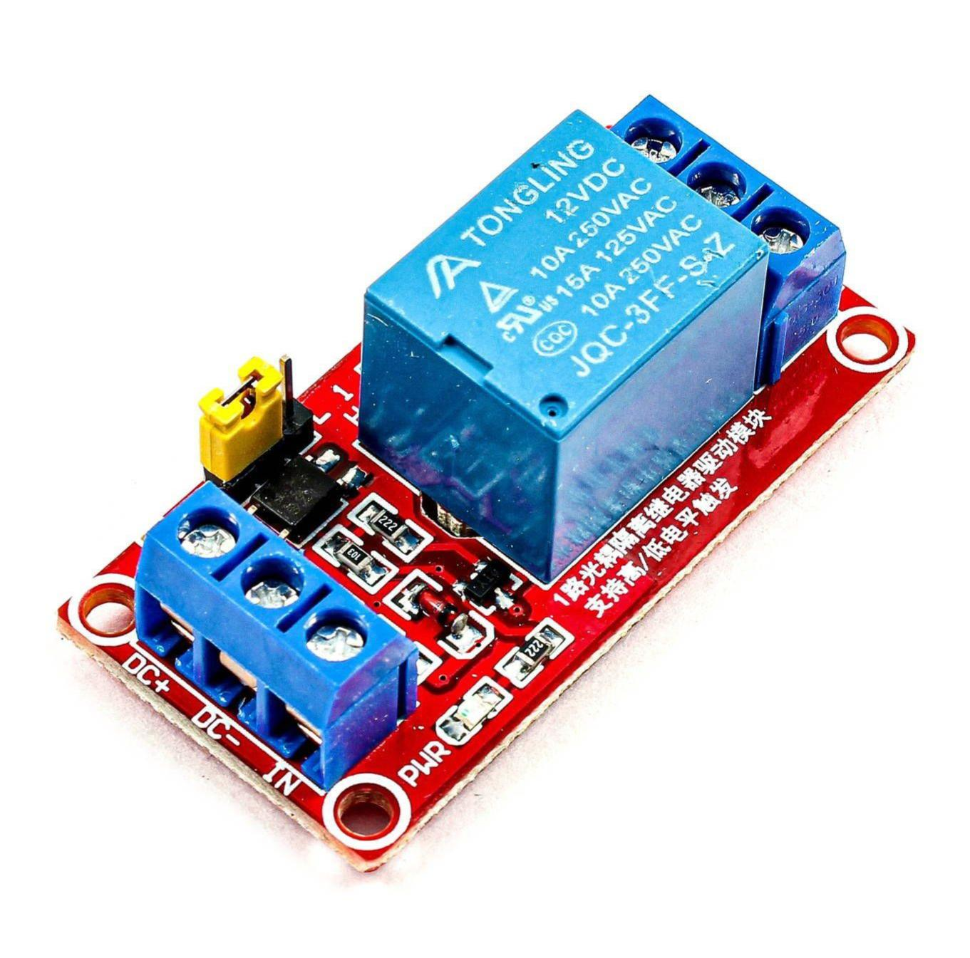

**WORKING OF A SOUND SENSOR**

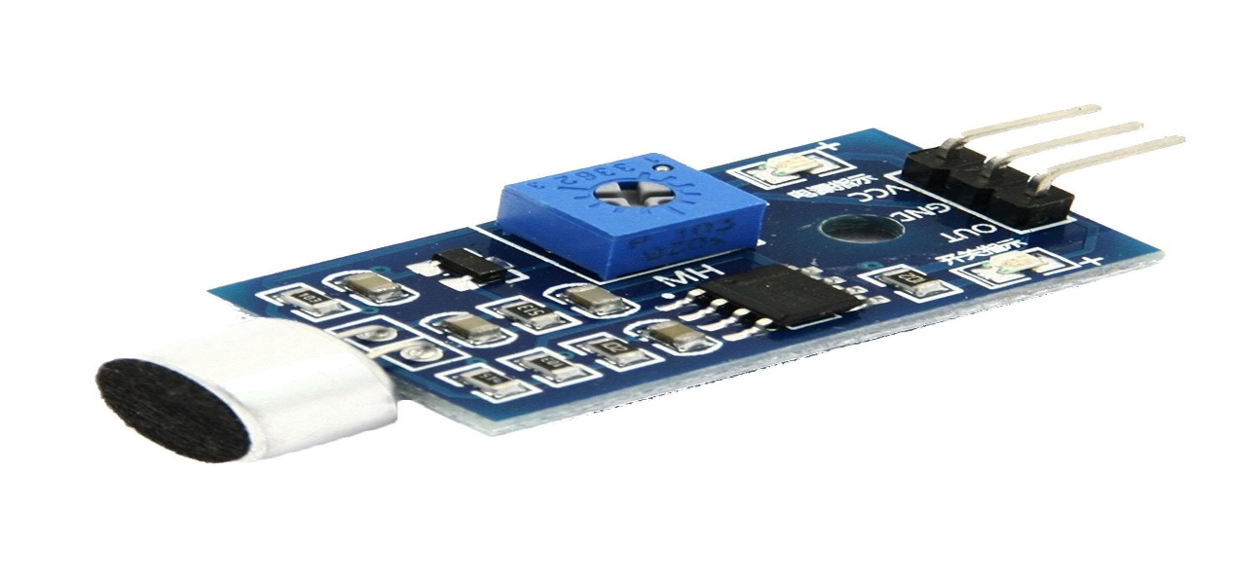 The sound sensor module is a simple electric Microphone based electronic board used to sense external sound from the environment. It is based on the LM393 power amplifier and an electret microphone ., It can be used to detect wether there is any sound beyond the set threshold limit. The module output is a digital signal which indicates that the sound is greater or lesser than the threshold

The potentiometers can be used to adjust the sensitivity of the sensor module . The module output is HIGH/ LOW when the sound source is Lower / high than the threshold set by the potentiometer same sound sensor module can also be used for measuring the sound level is decibel .

The complete program of this Arduino water fountain projects is given at the bottom of the page. But here I am just explaining that by parts for better understanding

int sensor = A6;

int redled = 12;

int greenled=11;

int pump = 10;

# define REF 700

delay (70) ;

}

Printmode (sensor, INPUT) ;

Pinmode (redled, OUTPUT) ;

Pinmode (greenlet, OUTPUT);

}

Void loop ()

{

int sensor – value = analog read sensor

if ( sensor – value > REF )

{

digitalwrite ( greenled, HIGH);

digitalwrite (redled, HIGH ) ;

digitalwrite (pump, HIGH) ;

delay (70);

}

else

{

digitalwrite ( greenled, LOW );

digitalwrite (redled, LOW);

digitalwrite (pump, LOW) ;

delay (70);

}

}

**PHASE 2**

**INNOVATION**

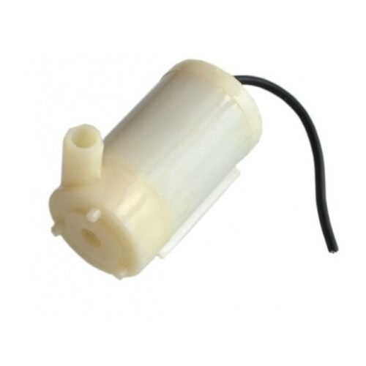

**1. Hydration Tracking:**

Create a water fountain that integrates with a smartphone app to track users' hydration levels. It could provide reminders to drink water based on individual needs and send data to health apps.

**2. Water Quality Monitoring:**

Install sensors to monitor water quality in real-time. Users can check water purity levels and receive alerts if any issues arise, promoting safe drinking.

**3. Touchless Operation:**

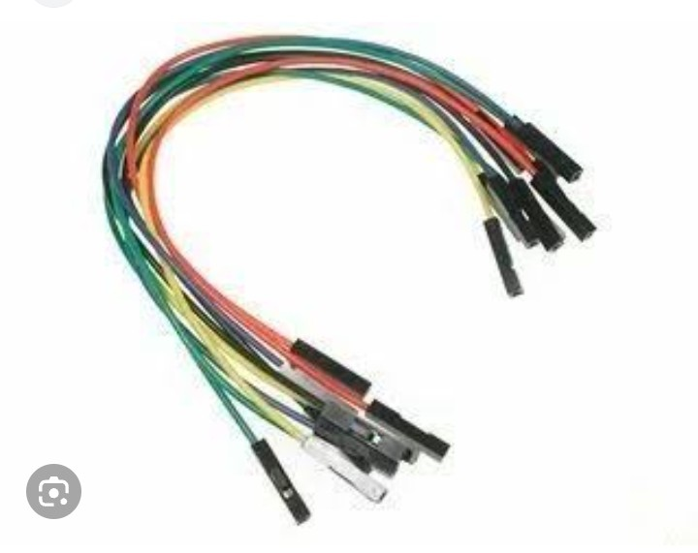 Implement touchless or gesture-based controls to minimize the spread of germs. Users can activate the fountain without physically touching any buttons.

**4. Personalized Dispensing:**

Customize water temperature and carbonation levels to suit individual preferences. Users can choose between cold, room temperature, or sparkling water.

**5. Sustainability Features:**

Make the fountain eco-friendly by incorporating a water purification system and using materials that reduce waste and energy consumption.

**6. Voice Assistant Integration:**

Enable voice-activated controls using popular voice assistants like Alexa or Google Assistant for a seamless user experience.

**7. Water Usage Analytics:**

Collect data on water consumption patterns and offer insights to encourage users to reduce water waste and stay hydrated.

**8. Maintenance Alerts:**

Equip the fountain with sensors that detect maintenance needs and automatically send alerts to facility managers.

**9. QR Code Information:**

Display QR codes linking to information about the water source, filtration process, and sustainability efforts, promoting transparency.

**10. Bottle Refill Stations:**

Include bottle refill stations with customizable bottle-filling option

s, such as volume control and water temperature.

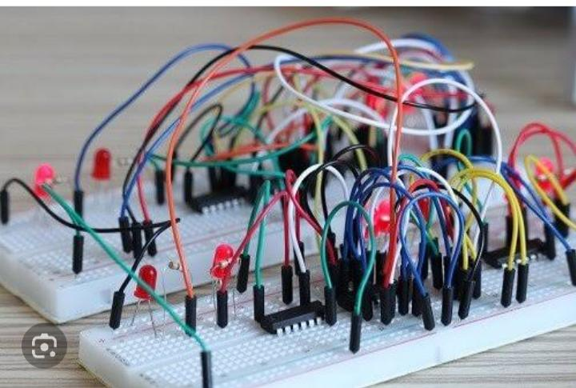

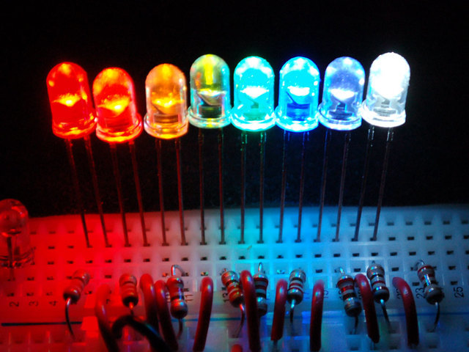

**11. User-Friendly Design:**

Focus on an ergonomic and aesthetically pleasing design that encourages people to use the fountain.

**12. Water Dispensing Games:**

Gamify the experience by adding interactive elements like quizzes or trivia that users can engage with while filling their water bottles.

**13. Eco-Education:**

Use digital displays to educate users about the importance of water conservation and sustainable practices.

**14. UV-C Sterilization:**

Incorporate UV-C sterilization technology to ensure that the fountain's dispensing area remains sanitary.

**15. Mobile App Integration:**

Allow users to locate nearby smart water fountains using a mobile app, making it convenient to find clean water on the go.

